1. Make working GUI for game:

* Main menu
* Scenes gui:

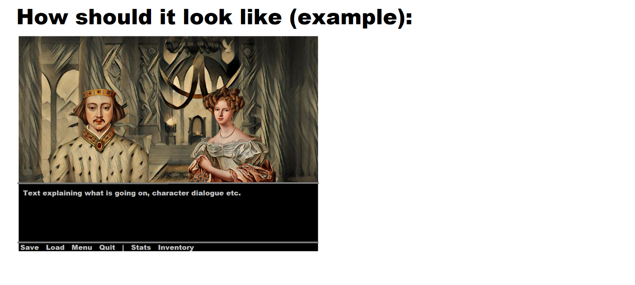

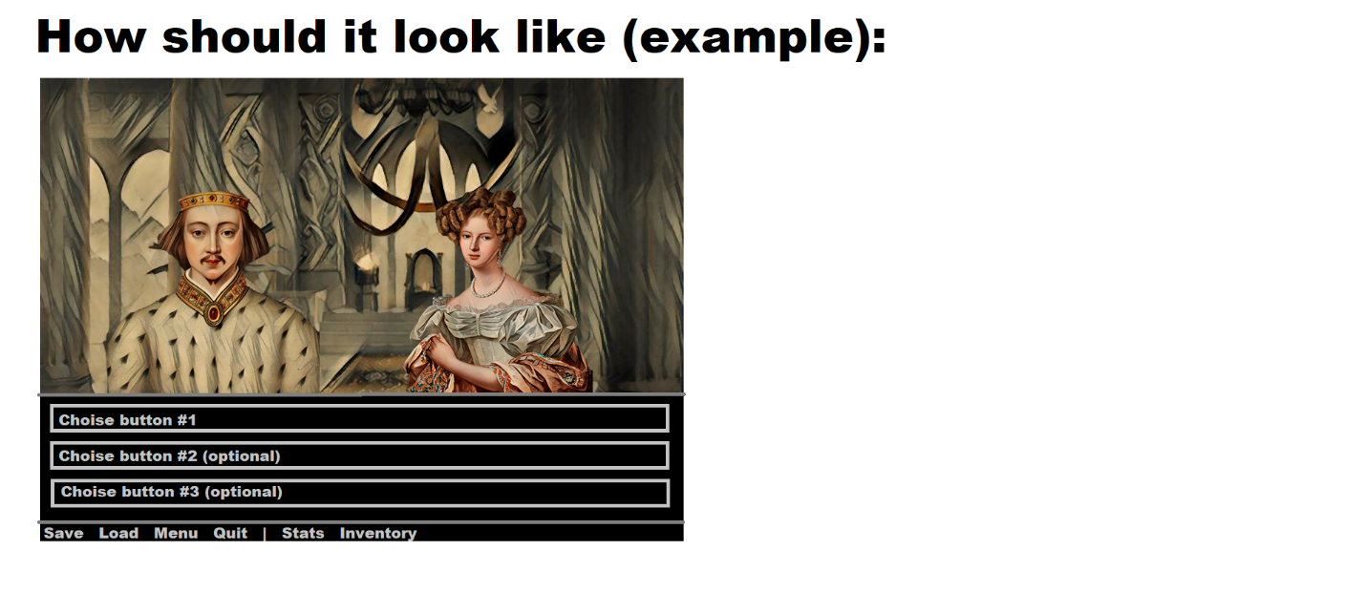

1. Make templates for scenes this way, what for new scene creation would be required just to change background (picture), add dialogues and music (process of new text adding should be as simple as possible), change text on buttons and add links, to link each button with next scene.

All have to work so:  
Each scene has its own number, when player is clicking on a button, another scene is being called.  
As example, player now on scene #1, he reads dialogues, then is clicking on button, what is linked to scene # 14. After that scene #14 is being called, with its picture, music, dialogues, buttons etc.

1. Buttons should also have opportunity to be programmed in more complicated ways. Some of them must disappear if conditions are not fulfilled (mechanics). Please test that.

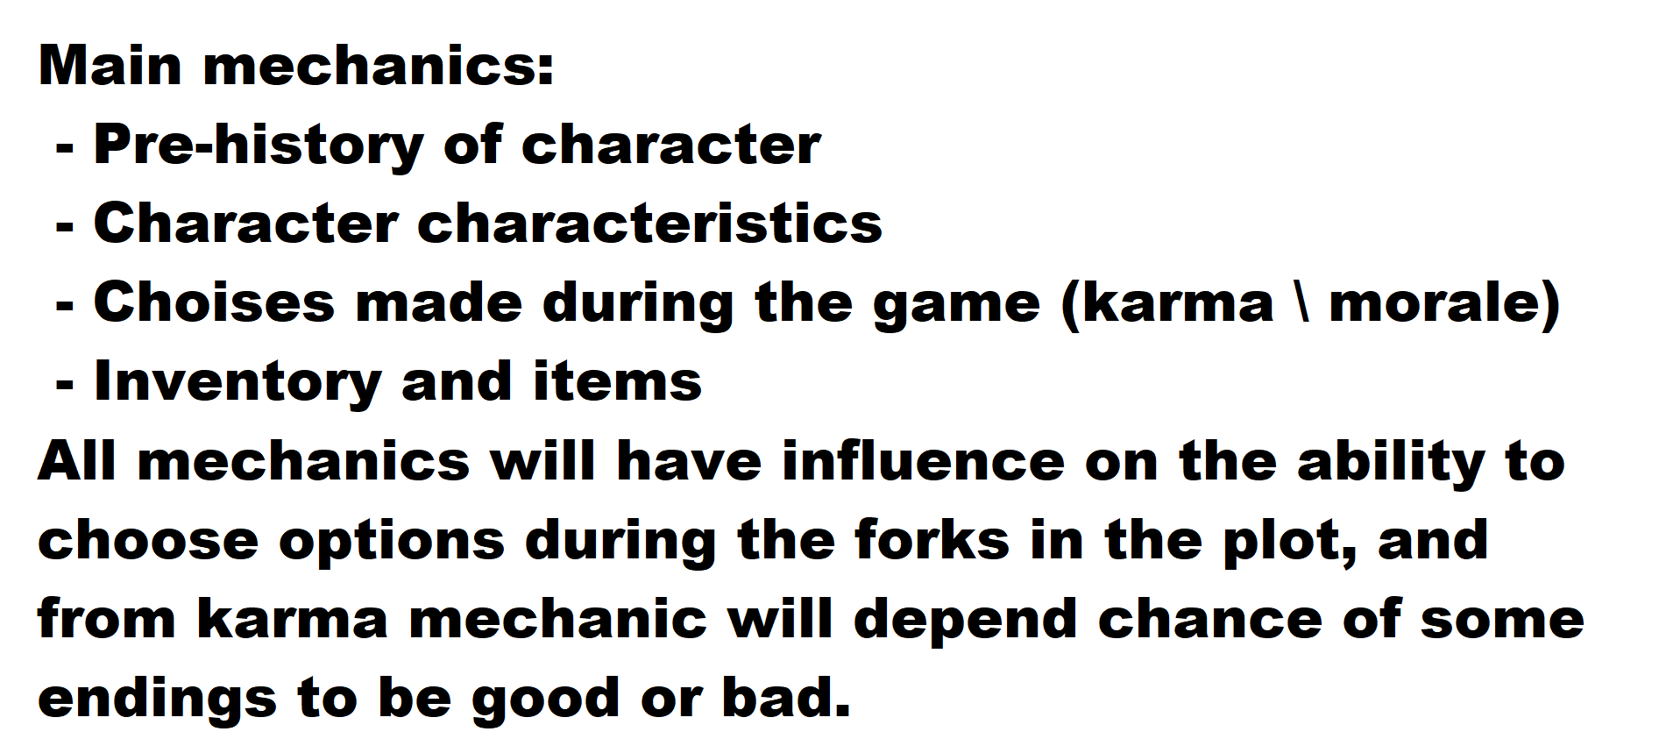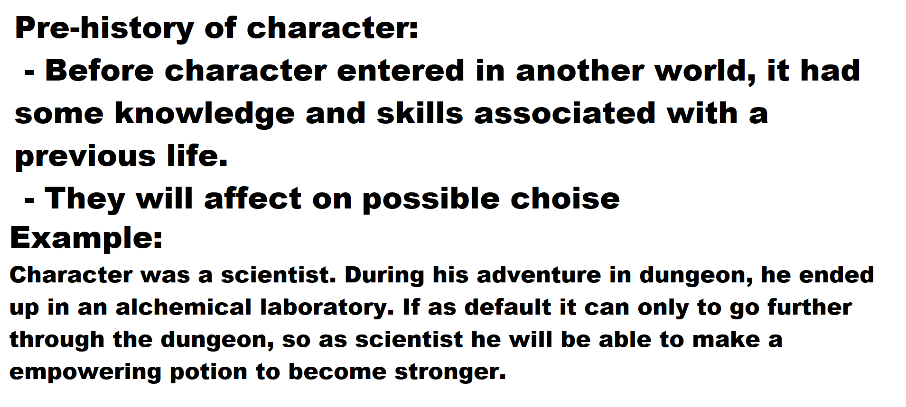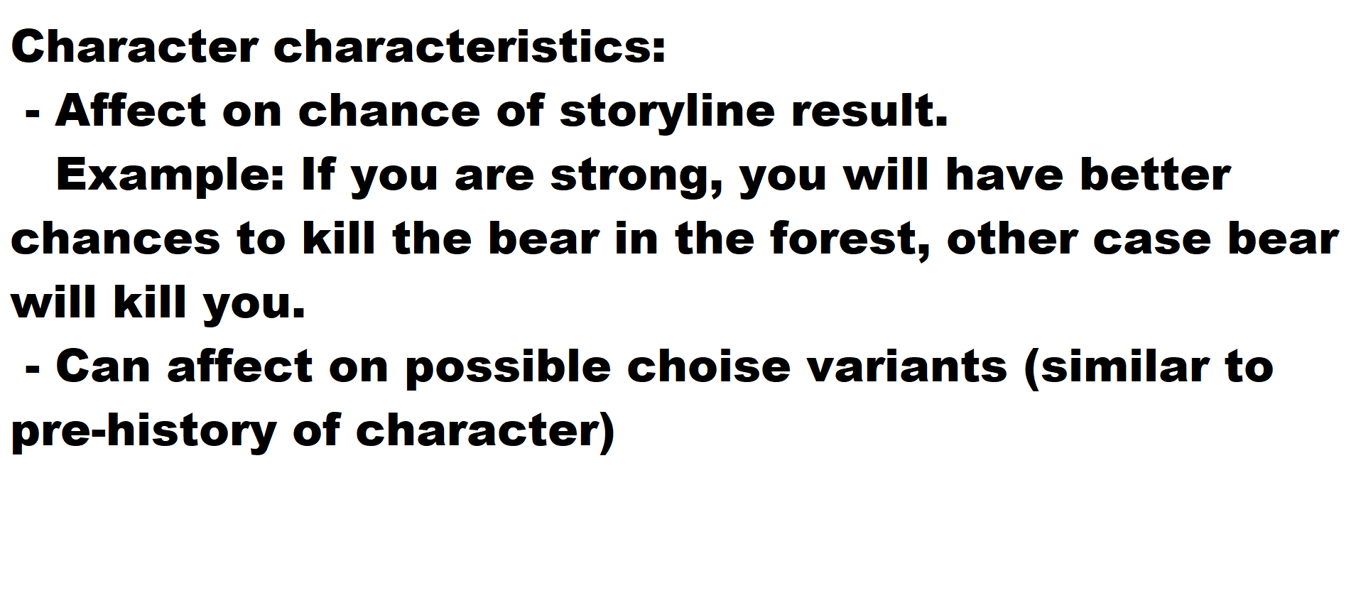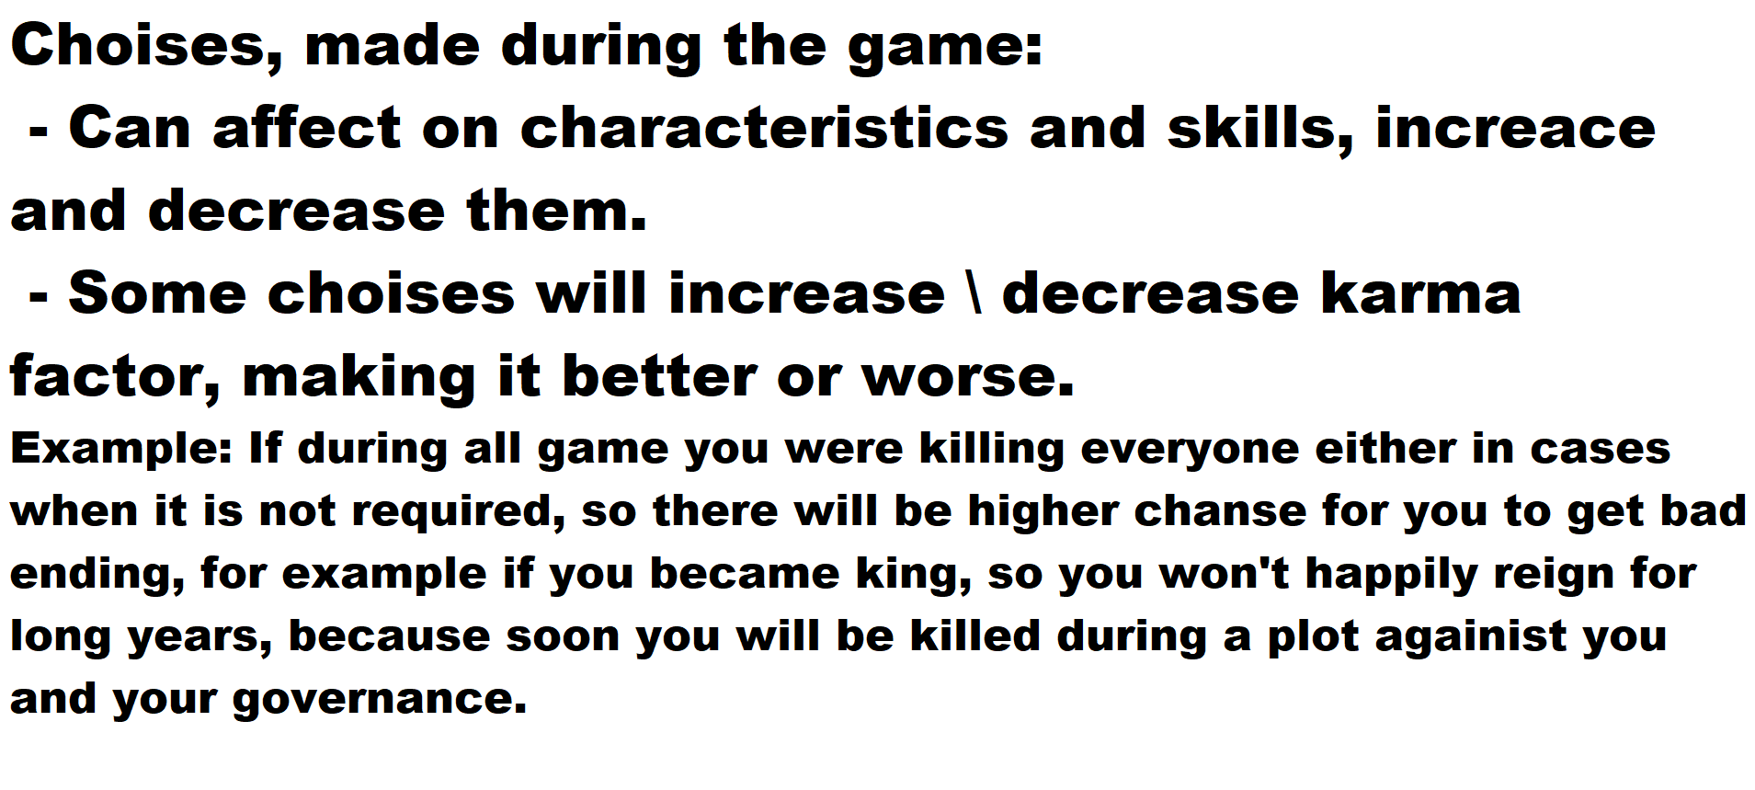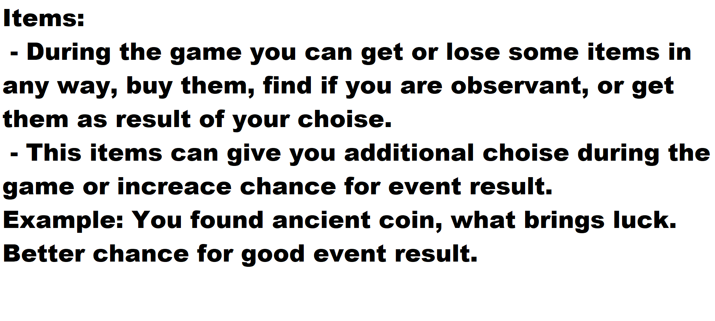

1. Create basic inventory, what consist of slots for items and equipped items slots, like this:

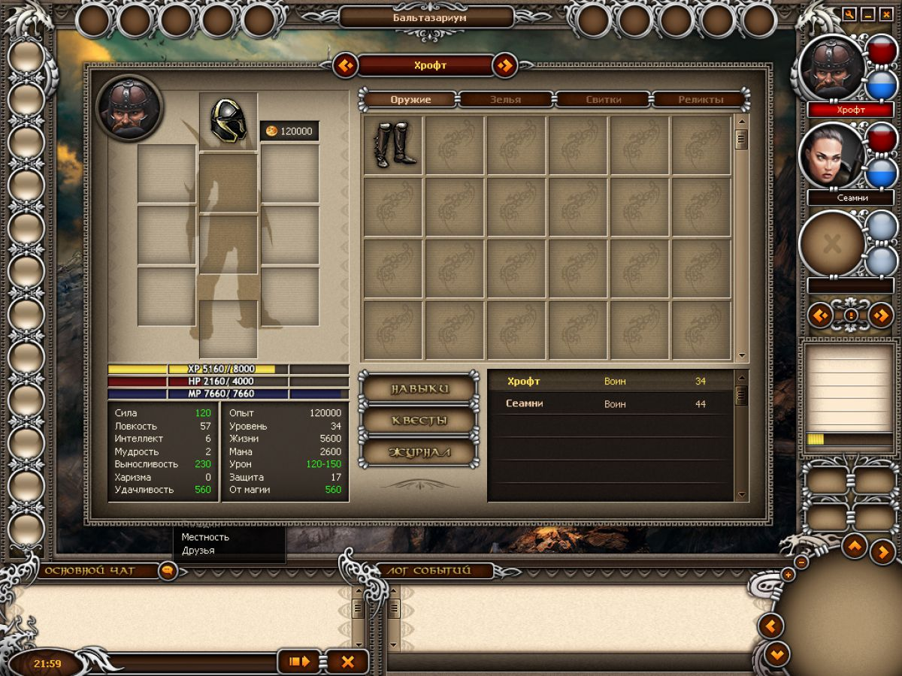

It is not needed to copy it, only known functionality is required.

1. If you will have enough time and you would want it, make system for saves creation.

If not, then we will do it on second week.